Mini Project Report
Title: CareerFlow Job Portal
Team Members
Member 1: Gauri Desai (03)
Member 2: Om Kanojiya (04)
Member 3: Parv Lakhani (06)
Member 4: Sandhvi Patil (11)
Member 5: Sumit Prajapati (20)

Problem Statement
Job seekers often face difficulty managing profiles, resumes, saved jobs, and repeated job applications across different platforms, while recruiters need a simple system to post jobs and monitor applicants efficiently. CareerFlow addresses this by providing a single portal where candidates can create profiles, upload resumes, save jobs, apply seamlessly, and where recruiters can post openings, view applications in real time, shortlist candidates, and manage interview scheduling.

Description
CareerFlow is a unified web-based job portal designed for two primary users: candidates and recruiters. On the candidate side, the platform supports profile creation, resume upload, saved jobs, and a streamlined application flow, including an auto-apply feature once required profile details are completed. On the recruiter side, the system provides interfaces for posting jobs, adding company details and logos, reviewing applications, shortlisting applicants, and scheduling interviews in an organized dashboard workflow.
The deployed project is hosted on Vercel and loads a bundled JavaScript file and CSS asset, which is consistent with a frontend single-page application architecture. The public description further indicates that the frontend uses React, Tailwind CSS, and Radix UI, while the backend is serverless and powered by Convex Database, with Google-based authentication for secure login.

Technology Used
The verified public project description identifies the core technology stack as React, Tailwind CSS, Radix UI, Convex Database, and Google Login authentication. The live deployment on Vercel also shows asset-bundled frontend delivery through JavaScript and CSS files, confirming a web client built with modern frontend tooling.
Category | Technology
Client-side language | JavaScript
Client-side library/framework | React
Styling/UI | Tailwind CSS, Radix UI, CSS
Server-side / backend platform | Convex serverless backend
Database | Convex Database
Authentication | Google Login
Deployment | Vercel

Layout Design Snapshots
The live site was reachable and returned the production HTML shell for a single-page app, but the fetched public HTML alone does not expose visual page sections or screenshots because the interface is rendered through client-side JavaScript after load. For your report, you should add screenshots of the actual UI from your browser, ideally covering the home page, login page, candidate dashboard, recruiter dashboard, job posting page, and application management page.
Suggested snapshot captions:
- Home page / landing page.
- Login and sign-up page.
- Candidate profile and resume upload page.
- Job listings and saved jobs page.
- Recruiter job posting page.
- Applicant tracking / interview scheduling dashboard.

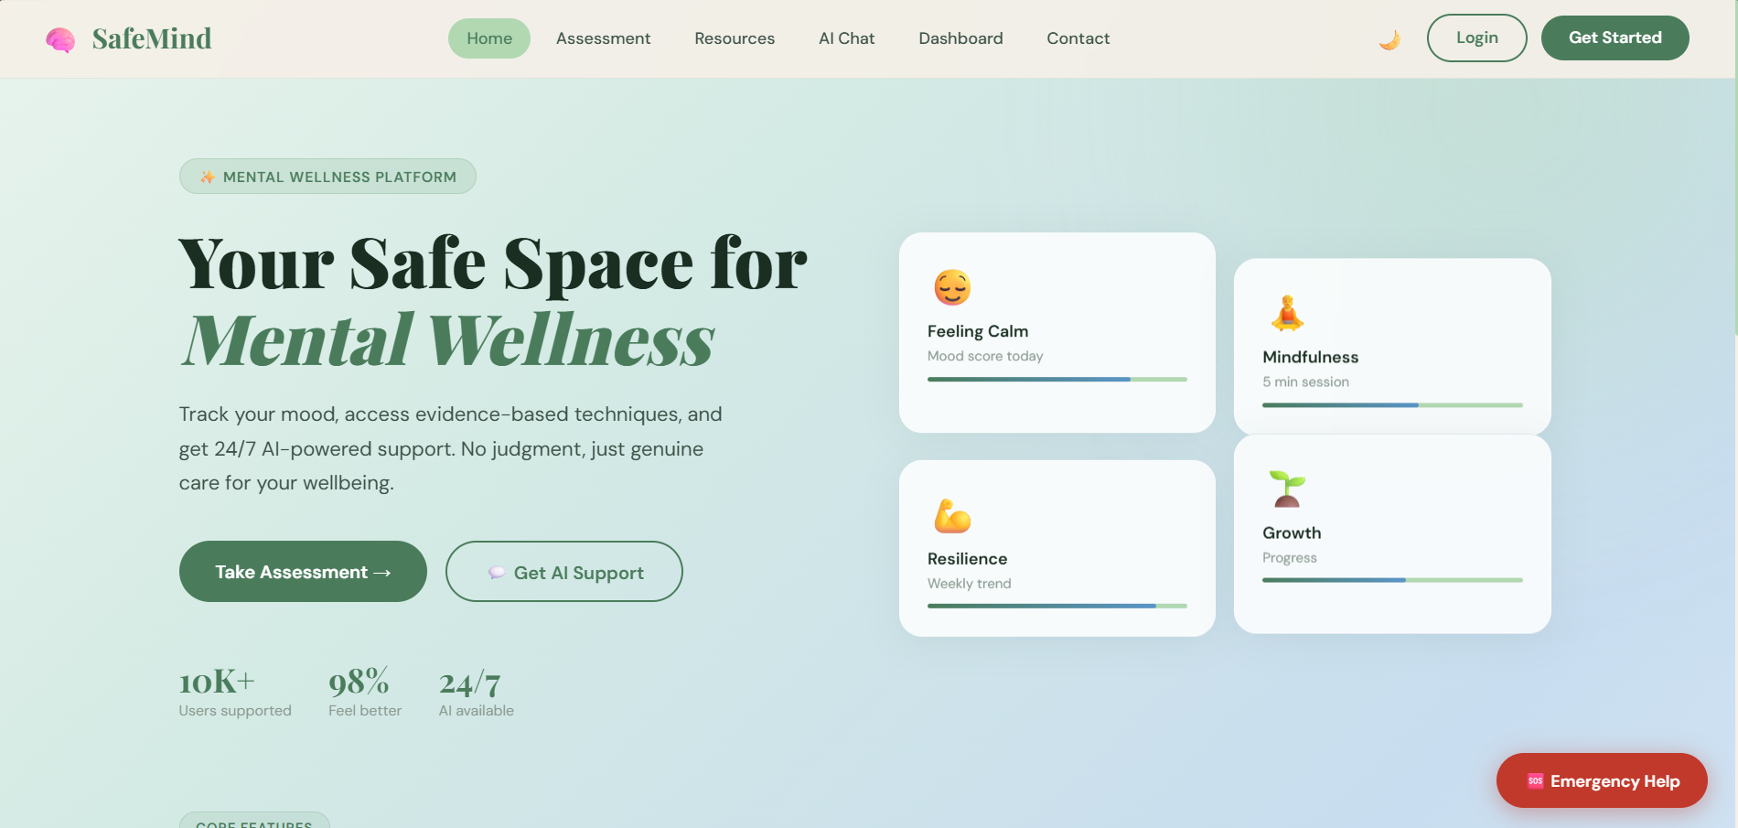

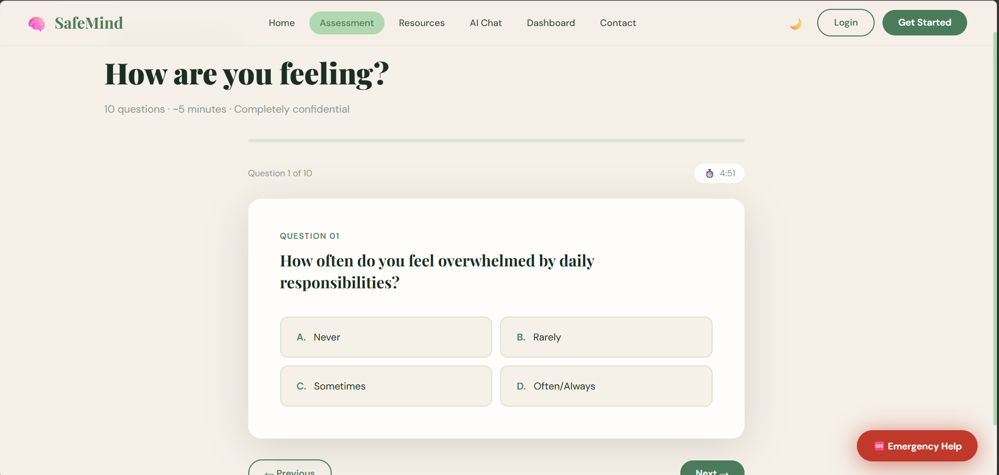

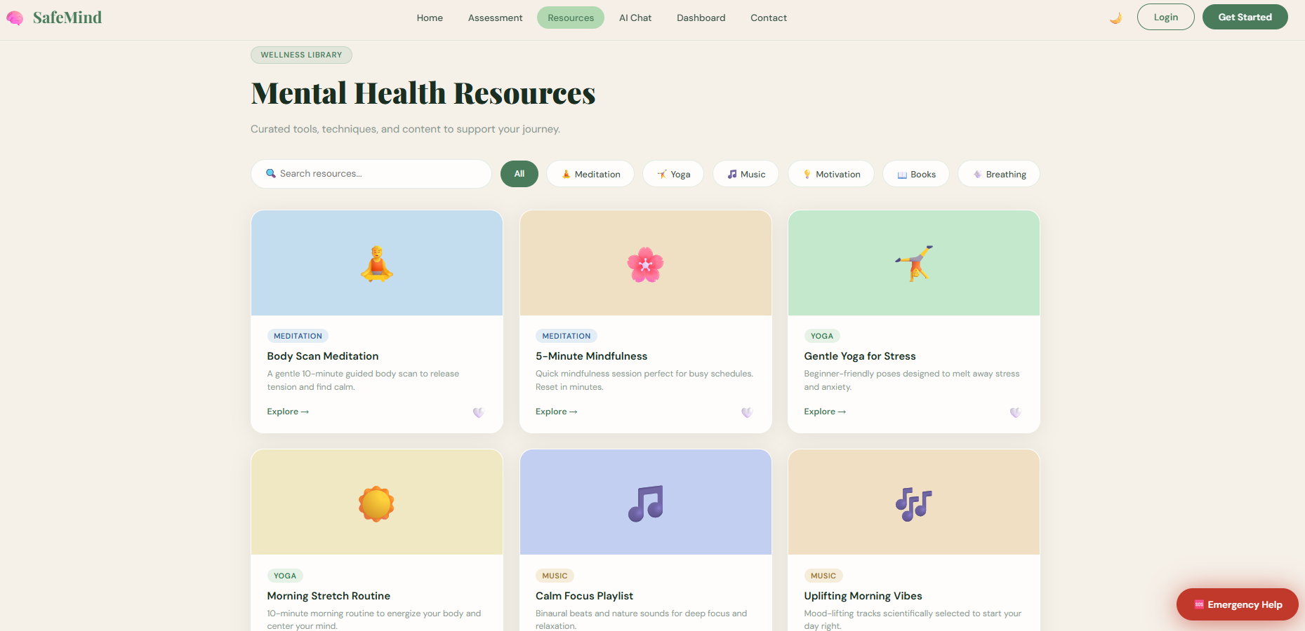

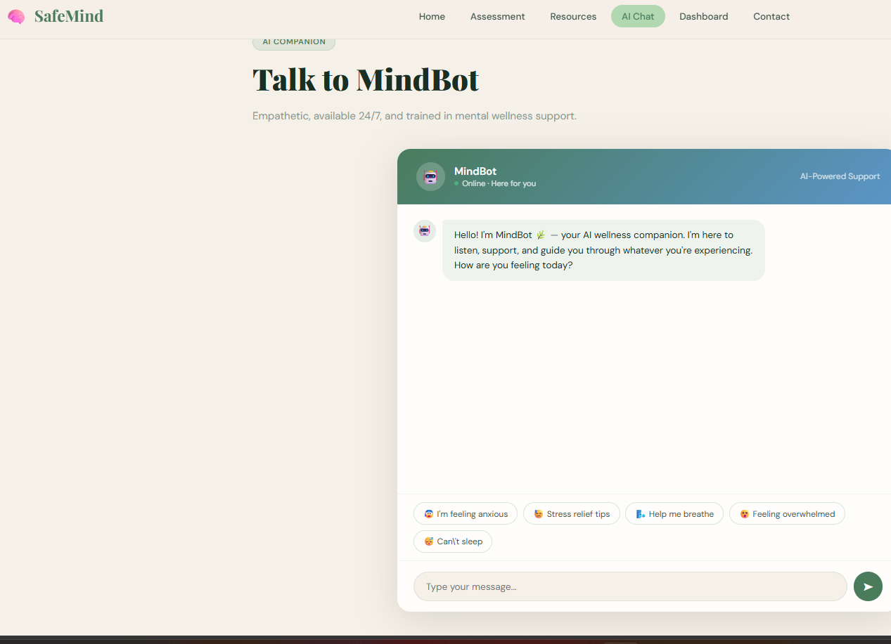

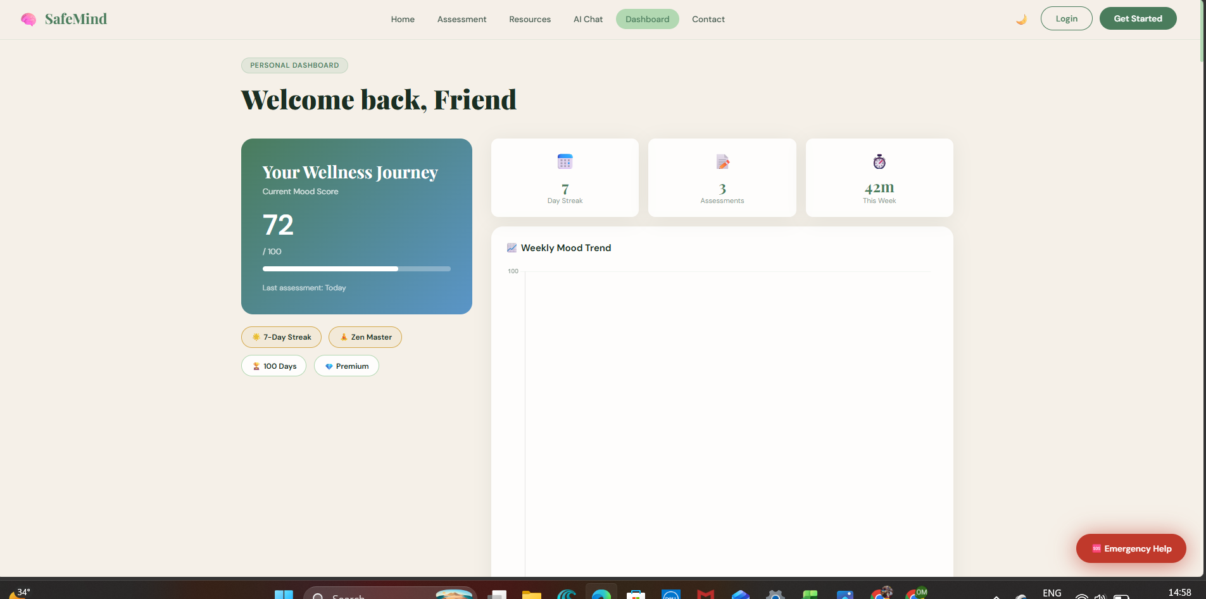
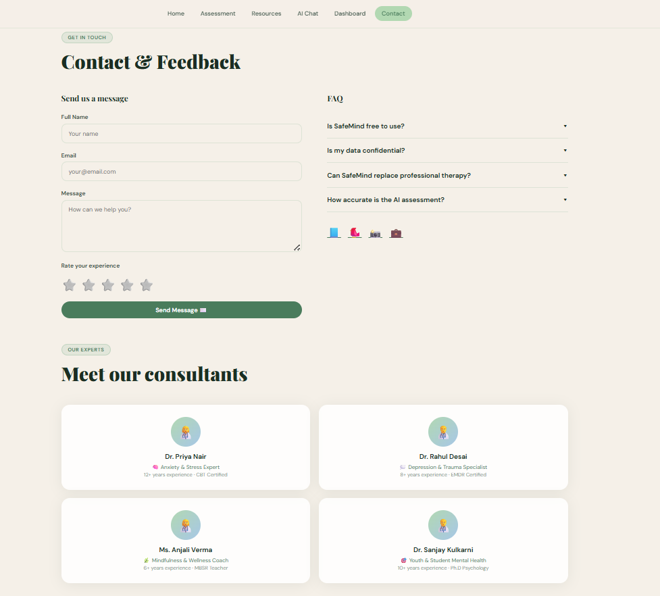

Database Design
The public description confirms the use of Convex Database and mentions real-time application visibility for recruiters, which suggests a structured data model for users, jobs, applications, and interview scheduling. Based on the verified feature set, a suitable database design would include entities such as Candidates, Recruiters, Companies, Jobs, Applications, SavedJobs, Resumes, and Interviews, with relationships linking users to jobs and applications in real time.
A simple conceptual database structure for the report can be written as:
- Users: user_id, name, email, role, auth_provider.
- Candidates: candidate_id, user_id, resume_url, skills, profile_status.
- Recruiters: recruiter_id, user_id, company_id, designation.
- Companies: company_id, company_name, logo_url, location.
- Jobs: job_id, recruiter_id, company_id, title, description, salary, location, job_type, posted_date.
- Applications: application_id, job_id, candidate_id, status, applied_date.
- SavedJobs: saved_id, candidate_id, job_id, saved_date.
- Interviews: interview_id, application_id, interview_date, mode, remarks.
Conclusion
CareerFlow is a practical and relevant mini project because it solves real hiring and job-search problems through one integrated portal for candidates and recruiters. Its use of React for the frontend, Tailwind CSS and Radix UI for interface design, Convex for serverless backend and database support, Google authentication, and Vercel deployment makes it a modern full-stack web application suitable for academic presentation and demonstration.

